ASSIGNMENT

***ARRAYS AND POINTER***

***WAQAS ASHIQ.***

***BCS-F11-201.***

***SECTION C.***

***SUBMITTED TO : SIR DR.ALI HASSAN.***

EXERCISE:1

CODE:

#include<stdio.h>

#include<stdlib.h>

#include<time.h>

int main()

{

int roll1;

int roll2;

int sum=0;

int a[3600];

int counter2=0;

int counter3=0;

int counter4=0;

int counter5=0;

int counter6=0;

int counter7=0;

int counter8=0;

int counter9=0;

int counter10=0;

int counter11=0;

int counter12=0;

for(int i=0; i<3600;i++)

{

srand(time(NULL));

roll1=1+rand()%6;

roll2=1+rand()%6;

sum=roll1+roll2;

sum=a[i];

scanf("%d",&a[i]);

sum=roll1+roll2;

if(sum==2)

{

counter2++;

}

if(sum==3)

{

counter3++;

}

if(sum==4)

{

counter4++;

}

if(sum==5)

{

counter5++;

}

if(sum==6)

{

counter6++;

}

if(sum==7)

{

counter7++;

}

if(sum==8)

{

counter8++;

}

if(sum==9)

{

counter9++;

}

if(sum==10)

{

counter10++;

}

if(sum==11)

{

counter11++;

}

if(sum==12)

{

counter12++;

}

printf("num of output in which sum is 2:%d\n",counter2);

printf("num of output in which sum is 3:%d\n",counter3);

printf("num of output in which sum is 4:%d\n",counter4);

printf("num of output in which sum is 5:%d\n",counter5);

printf("num of output in which sum is 6:%d\n",counter6);

printf("num of output in which sum is 7:%d\n",counter7);

printf("num of output in which sum is 8:%d\n",counter8);

printf("num of output in which sum is 9:%d\n",counter9);

printf("num of output in which sum is 10:%d\n",counter10);

printf("num of output in which sum is 11:%d\n",counter11);

printf("num of output in which sum is 12:%d\n",counter12);

}

}

OUTPUT:

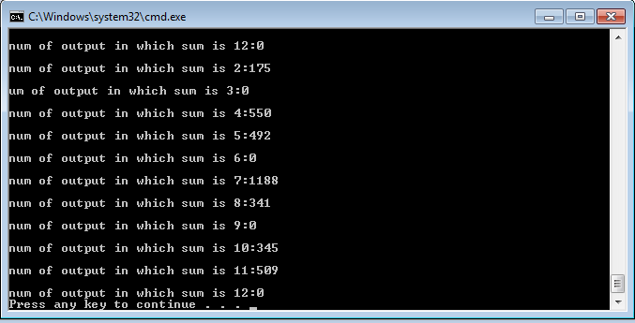

EXERCISE:2

CODE:

#include<stdio.h>

#include<stdlib.h>

int product[4][5];

void get_sales();

void print_sales();

int main()

{

get_sales();

print_sales();

printf("\n\n\n\n\n\n\n");

return 0;

}

void get_sales()

{

for(int x=0;x<4;x++)

{

printf("\nEnter sales person's prodcuts %d",x);

for(int y=0;y<5;y++)

{

printf("\nEnter sale:");

scanf("%d",&product[x][y]);

}

}

}

int total_sales(int x)

{

int sum=0;

for(int y=0;y<=4;y++)

{

sum=sum+product[x][y];

}

return sum;

}

void total_product()

{

for(int y=0;y<=4;y++)

{

int sum=0;

for(int x=0; x<4;x++)

{

sum=sum+product[x][y];

}

printf("\t%d",sum);

}

}

void print_sales()

{

printf("\tprdct1\tprdct2\tprdct3\tprdct4\tprdct5\ttotalsales\n");

for(int x=0;x<4;x++)

{

printf("sale:%d",x);

for(int y=0;y<=4;y++)

{

printf("\t%d",product[x][y]);

}

int s=total_sales(x);

printf("\t%d",s);

printf("\n\n");

printf("*************************************************\n");

}

printf("\nprdt sm");

total_product();

}

OUTPUT:

